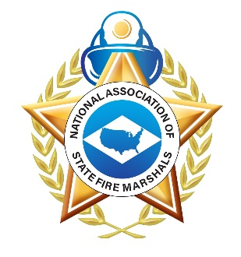
National Association of State Fire Marshals

32nd Annual Fire Prevention & Safety Symposium
Call For Presentations

We’re looking for dynamic and passionate speakers who are considered experts in the following areas of fire & life safety:
- Wildland/WUI-prevention, mitigation, and recovery
- Fire Investigation
- Community Risk Reduction-partnerships, programs, and analysis
- Code development, adoption, and enforcement
- Fire Service wellness
- Data gathering and analysis
- Emerging topics and technology

If the following details describe you, we would love to see your proposal!
- Your presentation is geared towards high-level policy instead of in-the-field decision-making
- Your presentation is applicable for a wide level of knowledge and experience of attendees.
- You include case studies, relevant examples, or real-life experiences in your presentation to detail or highlight a specific topic.
- You encourage audience participation, open dialogue, and facilitated discussion.
- Your motivation for presenting is to educate, not sell.
- You have no problem meeting deadlines.
If this sounds like you, please complete the following form and return it to the NASFM selection committee via email at jon@narvaassociates.com no later than 5:00 PM Eastern on June 15th, 2022.

Name: Click or tap here to enter text.
Organization: Click or tap here to enter text.
Contact Information
Phone: Click or tap here to enter text.
Email: Click or tap here to enter text.
Address: Click or tap here to enter text.
Website: Click or tap here to enter text.
Speaker Bio: (Limit 75 words) Click or tap here to enter text.
Are you proposing a panel or solo presentation? Click or tap here to enter text.

Topic Title: (Maximum 20 words) Catchy titles are good, just make sure they speak to the content. Click or tap here to enter text.
Length of Presentation: ☐30 Min ☐45 Min ☐1 Hour
Session Abstract/Description (Maximum 200 Words) Click or tap here to enter text.
4 Session Objectives (What will attendees learn?) Answer the question... You will leave this session with...
Click or tap here to enter text.
Click or tap here to enter text.
Click or tap here to enter text.
Click or tap here to enter text.
Why is this topic important to this audience? Click or tap here to enter text.

